EMPLOYEE PAYROLL SYSTEM
Cornerstone Project Documentation
Submitted to Aditya University in partial fulfilment of the requirements for the award of B.Tech.
Artificial Intelligence & Machine Learning (2026-2027)
SUBMITTED BY

U. Deepika 25B11AIC25
B.P. Sri Chandana 25B11AI129
Y. Renuka Lahari 25B11AIC88
CH. Sahithi 25B11AI210

UNDER THE GUIDANCE OF

Guide Name – Mr. V . Appalakonda
Designation- Assistant professor

Department of Artificial intelligence and Machine learning

Aditya University, Aditya Nagar, ADB Road,
Surampalem, Kakinada, District, Andhra Pradesh, India - 533437

DECLARATION

We hereby declare that the Cornerstone project work entitled “Employee Payroll System” is being submitted for the award of the B. Tech Degree in Computer Science and Engineering, Aditya University, Aditya Nagar , ADB Road, Surampalem . This project is a record of original work carried out by us. We further declare that this project has not been submitted, either in full or in part, for the award of any degree or diploma in this or any other institution.
We also confirm that the work has been carried out with academic honesty and complies with the Institutional Academic Integrity and AI Usage Policy.
Submitted By
U. Deepika – 25B11AIC25
B.P. Sri Chandana – 25B11AI129
Y. Renuka Lahari – 25B11AIC88
CH. Sahithi – 25B11AI210
Place: Surampalem
Date:

DEPARTMENT OF ARTIFICIAL INTELLIGENCE AND MACHINE LEARNING
ADITYA UNIVERSITY, ADITYA NAGAR,
SURAMPALEM.

CERTIFICATE

This is to certify that the cornerstone project entitled “EMPLOYE PAYROLL SYSTEM ” is being submitted by U. Deepika - 25B11AIC25 , B.P. Sri Chandana – 25B11AI129, Y. Renuka Lahari – 25B11AIC88 , CH. Sahithi – 25B11AI210 in partial fulfilment for the award of B. Tech Degree from Aditya University, is a record of original work done by them under my supervision. The contents of this project, in full or in parts, have not been submitted to any other Institute or University for the award of any degree or diploma.

Project Guide
Mr . V . Appalakonda
Assistant Professor
Department of AIML
Aditya University

ACKNOWLEDGEMENT

It is with immense pleasure that we express our sincere gratitude to our Cornerstone Project Guide Mr. V. Appalakonda, Assistant proffessor, who has guided us throughout the project. Her valuable support, encouragement, and guidance have greatly contributed to the successful completion of this work.
Our deepest thanks to our Head of the Department, Dr. K. Naga Bhargavi, Associate Professor & HOD, for her inspiration and for providing all the necessary facilities and resources required for this project.
We also extend our sincere thanks to DR. M.V. RAJESH, ASSOCIATE DEAN, SCHOOL OF COMPUTING, for his encouragement and support during our project.
We would like to express our sincere gratitude to DR. G. SURESH, REGISTRAR; DR. A. RAMESH, PRO VICE-CHANCELLOR (ENGINEERING & SCIENCES); DR. S. RAMA SREE, PRO VICE-CHANCELLOR (ACADEMICS); DR. M.B. SRINIVAS, VICE-CHANCELLOR; AND DR. M. SREENIVASA REDDY, DEPUTY PRO CHANCELLOR AND MANAGEMENT, ADITYA UNIVERSITY, for providing excellent infrastructure and state-of-the-art laboratories.
Finally, we would like to thank the FACULTY MEMBERS, LAB TECHNICIANS, NON-TEACHING STAFF, AND OUR FRIENDS who have directly or indirectly supported us in completing this Cornerstone project successfully.

Name of the Students
U. Deepika – 25B11AIC25
B.P. Sri Chandana – 25B11AI129
Y. Renuka Lahari – 25B11AIC88
CH. Sahithi – 25B11AI210

Date:

ABSTRACT

The Employee Payroll System is a menu-driven C++ application developed using Object-Oriented Programming concepts. The purpose of the system is to maintain basic employee details and perform salary calculations in a simple and organized manner.
The application accepts employee ID, name, designation, and basic salary. It calculates sample salary components such as gross salary, and net salary and displays the payroll information in a readable format.
The project demonstrates classes, objects, encapsulation, member functions, loops, switch statements, formatted output, and modular programming. The design can be extended with multiple employees, file/database storage, attendance, tax, authentication, payslip generation, and a graphical or web interface.

ABBREVIATIONS

Abbreviation | Meaning
OOP | Object-Oriented Programming
C++ | C Plus Plus
GS | Gross salary
NS | Net salary
PF | Provident Fund
ID | Identification
I/O | Input/Output
UI | User Interface

LIST OF FIGURES

Figure No. | Figure Title
Figure 1 | System Architecture
Figure 2 | Overall Flowchart
Figure 3 | Main Menu
Figure 4 | Employee Input Screen
Figure 5 | Payroll Calculation Screen
Figure 6 | Payroll Display Screen
Figure 7 | Testing Workflow
Figure 8 | Future System Architecture

LIST OF TABLES

Table No. | Table Title
Table 1 | Employee Data Fields
Table 2 | Functional Requirements
Table 3 | Planned Modules
Table 4 | Object-Oriented Programming (OOP) Concepts
Table 5 | Salary Components
Table 6 | Test Cases
Table 7 | Advantages and Limitations
Table 8 | Future Enhancements

TABLE OF CONTENTS

CONTENTS
Title Page
Certificate
Declaration
Acknowledgement
Abstract
Abbreviations
List of Figures
List of Tables
CHAPTER -1 Project Planning
1.1. Problem statement
1.2. Project Objective
1.3. Planned Modules
1.4. System Architecture (Algorithm & Flowchart)
CHAPTER -2 Project Implementation
2.1. OOP Concepts Used for implementation
2.2. Code
2.3. Output Screens
CHAPTER-3 Conclusion & Future Scope
3.1. Conclusion
3.2. Future Scope

CHAPTER 1

PROJECT PLANNING

Problem Statement

Manual payroll processing requires employee information and salary calculations to be handled repeatedly. This can increase effort and may cause calculation or recording mistakes. A simple software system can organize employee data and perform salary calculations consistently.

Project Objectives

- Develop an easy C++ payroll application.
- Maintain employee details.
- Calculate salary components automatically.
- Reduce repeated manual calculations.
- Demonstrate practical OOP concepts.
- Provide a simple menu-driven interface.

Planned Modules

Module | Purpose | Operations
Employee Management | Collects and maintains employee details | Enter employee ID and name using addemployee( )
Salary Input | Accept the employee’s salary details | Enter basic salary, allowances, bonus, overtime pay, and other deductions.
Payroll Calculation | Calculates the employee's gross salary, total deductions, and net salary. | calculateGrossSalary(), calculateTotalDeductions(), calculateNetSalary().
Payroll Display | Displays employee details, earnings, deductions, and final salary. | displayDetails().
Menu Control | Controls program execution and allows users to select payroll operations. | do-while loop, switch statement, and menu options.

ALGORITHM AND FLOWCHART

1. Start program
2. Create Employee object
3. Display menu
4. Read choice
5. Choice 1: enter employee details
6. Choice 2: calculate salary
7. Choice 3: display payroll
8. Choice 4: exit
9. Invalid choice: show message
10. Repeat until Exit
11. Stop

Flowchart Description
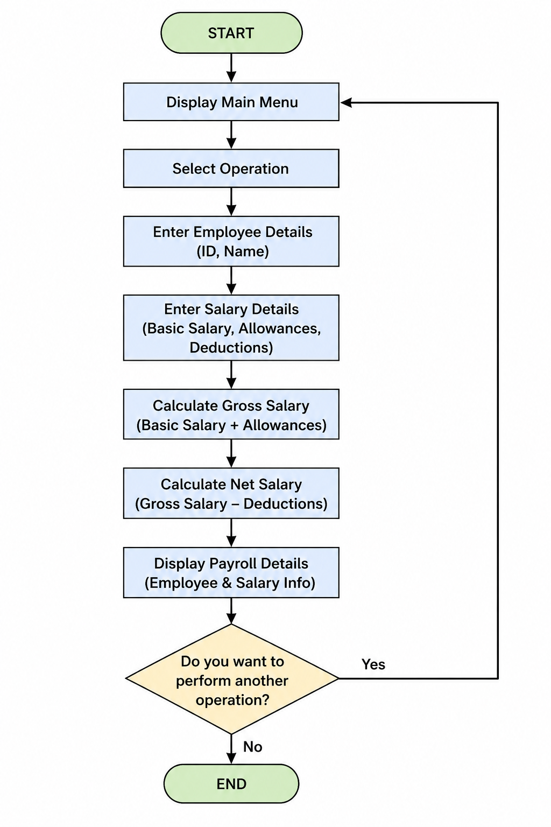
The flow provides continuous interaction until the user selects the Exit option.

CHAPTER 2

PROJECT ANALYSIS AND DESIGN

2.1 System Analysis

The application has a small number of closely related operations, so a class-based design is suitable. The Employee class contains the data and member functions needed for payroll operations.

2.2 Employee Data Design

S. No. | Data Member | Data Type | Purpose
1 | employeeId | string | Stores the unique identification number of the employee.
2 | employeeName | string | Stores the name of the employee.
3 | basicSalary | double | Stores the basic salary of the employee.
4 | allowances | double | Stores the additional allowances provided to the employee.
5 | bonus | double | Stores the bonus amount paid to the employee.
6 | overtimePay | double | Stores the payment for overtime work.
7 | pf | double | Stores the Provident Fund (PF) deduction, calculated as 12% of the basic salary.
8 | tax | double | Stores the tax deduction, calculated as 5% of the gross salary.
9 | otherDeductions | double | Stores any additional deductions from the employee's salary.

2.3 Salary Calculation Design
For this academic implementation, sample percentages are used.
Gross Salary = Basic Salary + allowances
Net Salary = Gross Salary − Deductions
These are project demonstration values and can be changed according to an organization's actual payroll policy.

2.4 Module Design

Employee Input Module collects employee information. Payroll Calculation Module performs salary calculations. Display Module shows the final payroll. Menu Module controls navigation.

2.5 Input/Output Design

S. No. | Input | Purpose | Output
1 | Employee ID | Identifies the employee uniquely. | Employee ID
2 | Employee Name | Stores the employee's name. | Employee Name
3 | Basic Salary | Provides the basic salary for payroll calculations. | Basic Salary
4 | Allowances | Specifies additional salary allowances. | Allowances
5 | Bonus | Specifies the bonus amount paid to the employee. | Bonus
6 | Overtime Pay | Specifies the payment for overtime work. | Overtime Pay
7 | Other Deductions | Specifies additional deductions from the salary. | Other Deductions
8 | Menu Choice | Allows the user to select an operation. | Employee details, payroll summary, or exit message
9 | Salary Components | Uses the entered salary details to calculate earnings and deductions. | Gross Salary
10 | Calculated Deductions | Calculates PF, tax, and other deductions. | Total Deductions
11 | Gross Salary and Total Deductions | Determines the final salary after deductions. | Net Salary
12 | Invalid Menu Choice | Handles an unsupported menu option. | Invalid choice message

2.6 ADVANTAGES AND LIMITATIONS

Advantages
- Easy to understand and operate.
- Reduces repeated calculations.
- Uses OOP for organized design.
- Easy to modify.
- Suitable for academic demonstration.

Limitations
- Current version focuses on one employee object.
- No permanent storage.
- Sample salary rules only.
- No authentication.
- No graphical interface.
- Limited validation.

Design Improvement Plan

Future versions can use vectors or databases for multiple records, validation for every input, configurable salary rules, authentication, and report generation.

CHAPTER 3

PROJECT IMPLEMENTATION

3.1 OOP Concepts Used

Concept | Application
Class | Employee class
Object | Employee object
Encapsulation | Private data + public functions
Member Functions | Addemployee( ), calculateGrosssalary( ),  calculateTotalDeduction( ), calculateNet salary( ), displayDetails( ), input, display
Constructor | Optional controlled initialization
Abbrevation | The calculation functions perform salary calculations internally and return the results without requiring the user

3.2 SOURCE CODE

#include <iostream>
#include <string>
using namespace std;

class Employee
{
private:
string employeeId;
string employeeName;

double basicSalary;
double allowances;
double bonus;
double overtimePay;

double pf;
double tax;
double otherDeductions;

public:

void addEmployee()
{
cout << "\nEnter Employee ID: ";
cin >> employeeId;

cin.ignore();

cout << "Enter Employee Name: ";
getline(cin, employeeName);

cout << "Enter Basic Salary: ";
cin >> basicSalary;

cout << "Enter Allowances: ";
cin >> allowances;

cout << "Enter Bonus: ";
cin >> bonus;

cout << "Enter Overtime Pay: ";
cin >> overtimePay;

cout << "Enter Other Deductions: ";
cin >> otherDeductions;

// PF = 12% of basic salary
pf = basicSalary * 0.12;

// Tax = 5% of gross salary
tax = calculateGrossSalary() * 0.05;
}

double calculateGrossSalary()
{
return basicSalary + allowances + bonus + overtimePay;
}

double calculateTotalDeductions()
{
return pf + tax + otherDeductions;
}

double calculateNetSalary()
{
return calculateGrossSalary() - calculateTotalDeductions();
}

void displayDetails()
{
cout << "\n========== EMPLOYEE PAYROLL ==========\n";

cout << "Employee ID : " << employeeId << endl;
cout << "Employee Name : " << employeeName << endl;

cout << "\n----- Earnings -----\n";

cout << "Basic Salary : " << basicSalary << endl;
cout << "Allowances : " << allowances << endl;
cout << "Bonus : " << bonus << endl;
cout << "Overtime Pay : " << overtimePay << endl;

cout << "Gross Salary : "
<< calculateGrossSalary() << endl;

cout << "\n----- Deductions -----\n";

cout << "PF : " << pf << endl;
cout << "Tax : " << tax << endl;
cout << "Other Deductions : " << otherDeductions << endl;

cout << "Total Deductions : "
<< calculateTotalDeductions() << endl;

cout << "\n----- Final Salary -----\n";

cout << "Net Salary : "
<< calculateNetSalary() << endl;
}
};

int main()
{
Employee emp;
int choice;

do
{
cout << "\n\n====================================";
cout << "\n EMPLOYEE PAYROLL SYSTEM";
cout << "\n====================================";

cout << "\n1. Add Employee";
cout << "\n2. Display Employee Payroll";
cout << "\n3. Calculate Payroll";
cout << "\n4. Exit";

cout << "\n\nEnter your choice: ";
cin >> choice;

switch(choice)
{
case 1:

emp.addEmployee();

cout << "\nEmployee details added successfully!";

break;

case 2:

emp.displayDetails();

break;

case 3:

cout << "\n========== PAYROLL SUMMARY ==========\n";

cout << "Gross Salary : "
<< emp.calculateGrossSalary() << endl;

cout << "Total Deductions : "
<< emp.calculateTotalDeductions() << endl;

cout << "Net Salary : "
<< emp.calculateNetSalary() << endl;

break;

case 4:

cout << "\nThank you for using Employee Payroll System!";

break;

default:

cout << "\nInvalid choice! Please try again.";
}

} while(choice != 4);

return 0;
}

3.3 SAMPLE OUTPUT

Main Menu
===== EMPLOYEE PAYROLL SYSTEM =====
1. Enter Employee Details
2. Calculate Payroll
3. Display Payroll
4. Exit

Employee Input

- Entering the Details of Employee
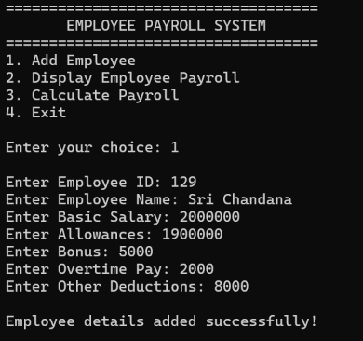

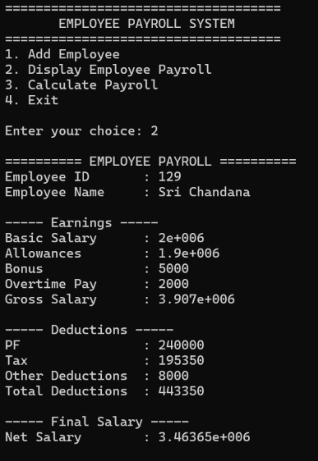

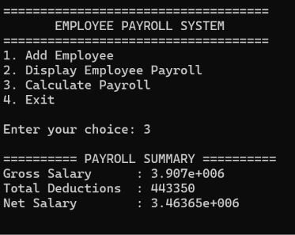

CHAPTER 3

CONCLUSION AND FUTURE SCOPE

3.1 Conclusion

The Employee Payroll System demonstrates how C++ and Object-Oriented Programming can be applied to a practical payroll problem. The class-based structure organizes employee data and payroll operations, while the menu-driven interface provides a simple user experience.
The project also provides experience in planning, designing, implementing, testing, and documenting a software application.

3.2 Future Scope

- Add file/database storage.
- Add search, update and delete.
- Integrate attendance and leave.
- Add overtime, bonus, tax and loan calculations.
- Generate monthly/yearly reports.
- Generate PDF payslips.
- Add login and role-based access.
- Develop GUI or web version.
- Add database connectivity.

